

11 PHYSICS

MEASUREMENT
& DATA

MEASUREMENT AND DATA

Units and Symbols

For almost all of the work done in Years 11 and 12, the SI (Système International) system of units will be used. There are just seven fundamental quantities that form the basis of all measurements in science.

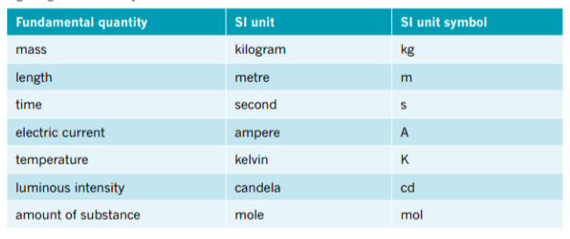

A derived unit is a combination of fundamental units.

e.g. A derived unit is the unit of velocity: metre per second. It is written m s^{–1}.

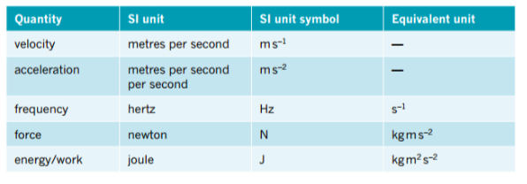

Scientific Notation

Measurements are often written in scientific notation. Quantities are written as a number between one and ten and then multiplied by an appropriate power of ten.

(Note that‘scientific notation’, ‘standard notation’ and ‘standard form’ all have the
same meaning.)

e.g. Some measurements written in scientific notation are:

0.054 m = 5.4 x 10⁻² m
245.7 J = 2.457 x 10² J
2080 N = 2.080 x 10³ N

You should be routinely using scientific notation to express numbers. An important reason for using scientific notation is that it removes ambiguity about the precision of some measurements.

e.g. A measurement recorded as 240 m could be a measurement to the nearest metre.
∴ Use 2.40 x 10² m.

The measurement may be to the nearest 10 m.
∴ Use 2.4 x 10² m.

Prefixes and Conversion Factors

You should be familiar with the prefixes and conversion factors in the table below. The table
gives all conversions as a multiplying factor.

Simply multiply the given number by the factor.

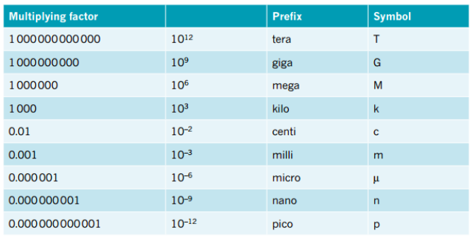

e.g. 2.45 x 10³ mm = 2.45 x 10³ x 10⁻³ = 2.45 m

2.45 x 10³ nm = 2.45 x 10³ x 10⁻⁹ = 2.45 x 10⁻⁶ m

1.25 x 10³ mm² = 1.25 x 10³ x (10⁻³)² = 1.25 x 10⁻³ m²
When calculating an area conversion, the factor is "squared".
For a volume conversion, the factor is "cubed".

To convert km h-1 to m s-1, divide by 3.60.

e.g. 70.0 km h⁻¹ = 70.0 ÷ 3.60 = 19.4 m s⁻¹

Examples

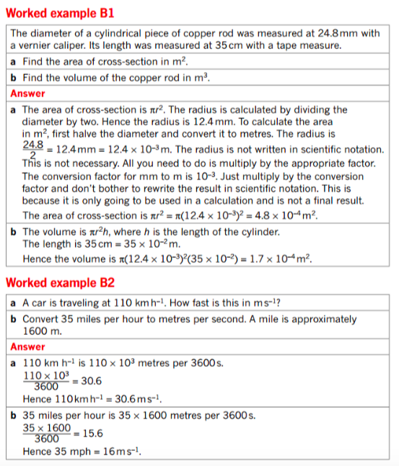
Uncertainty in Measurements

All measurements have some amount of uncertainty.

The uncertainty is one half of the finest scale division on the measuring instrument.

e.g. A measuring wheel has an uncertainty of 0.5 m (if it measures to the nearest metre).

A metre rule has an uncertainty of 0.5 mm (smallest division is 1.0 mm)

An electronic balance set to measure grams to two decimal places has an uncertainty of
0.005 g.

Sometimes this uncertainty is referred to as error. It is not error, in that it is not a mistake or something wrong. All measuring instruments have limited precision and the uncertainty is half of the smallest scale division on the instrument.

The uncertainty gives us the range in which a measurement falls. If we measured the length of a stick with a metre rule then we would get a measurement ‘plus or minus’ half a millimetre.

e.g. Any stick between 127.5 and 128.5 mm long would be measured as
128 mm to the nearest millimetre. We would record this as 128 ± 0.5 mm.

The best judgement you can definitely claim is one half of a scale division - it is too difficult to judge to a finer degree. The uncertainty we will still assume, however, is a full half scale
division.

e.g. You might measure another stick, one that has a length somewhere between 154 and
155 mm, as 154.5 ± 0.5 mm.

There are two ways to record uncertainties.

Absolute uncertainty: include the actual uncertainty in the measurement.

e.g. 154.5 ± 0.5 mm

Percentage uncertainty: expressed as a percentage of the measurement.

e.g. % uncertainty = 0.5/154.5 x 100% = 0.3%

∴ 154.5 ± 0.3 %

Uncertainty in Calculations

An experiment or a measurement exercise is not complete until the uncertainties have been analysed. The report should include an estimate of the total uncertainty. This gives the reader of the report some idea of your confidence in the result.

The following three processes are used for estimating uncertainty.

• When adding or subtracting data, add the absolute uncertainties.
• When multiplying or dividing data, add the percentage uncertainties.
• When raising data to power n, multiply the percentage uncertainty by n.

e.g. Calculate the area of a rectangle measuring 22.6 ± 0.1 mm (± 0.4 %) by
14.2 ± 0.1 mm (± 0.7%)

A = (22.6)(14.2) = 3.91 x 10² mm² ± 1.1%
= 3.91 x 10² ± 4 mm²

Example

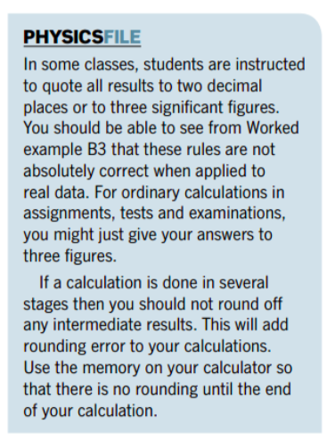
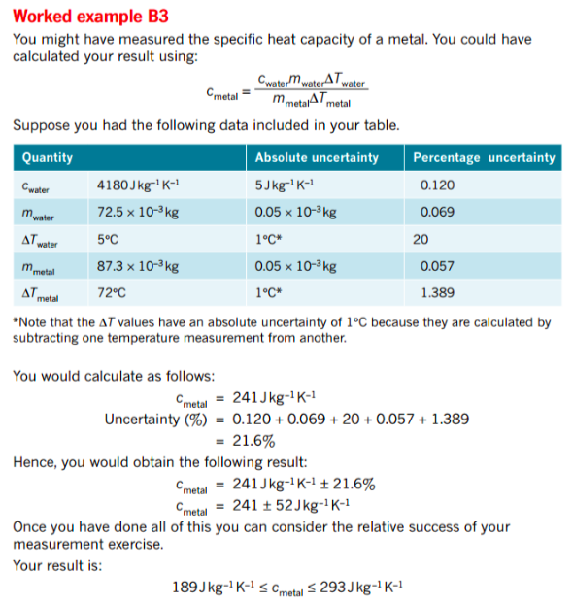

Significant Figures

Significant figures represent a way of expressing how confident we are in a measurement. The final digit carries an element of uncertainty - it has been rounded off.

e.g. An electronic balance measures a mass as 143.24 g.

This has 5 significant figures. The machine rounds the second decimal off to the
nearest number - it is the uncertain number.

Rules To Use

• All non-zero digits are significant.

• Zeroes between non-zero digits are significant.
e.g. 4003 has 3 s.f.

• Zeroes to the right of a decimal point and following a non-zero digit are significant.
e.g. 1.102 x 10³ has 4 s.f. 0.0105 has 3 s.f.

• All other zeroes are not significant.
e.g. 500 has 1 s.f.

If the zeroes are significant, write it in scientific notation - 5.00 x 10² has 3 s.f.

• In calculations, the final result should not contain any more significant figures than the data
with the least number of significant figures.

e.g. 2.45 x 5.6 x 103.23 = 1.4 x 10³
5.6 has 2 s.f. so the answer must have 2 s.f. - it has the least number of s.f.

GRAPHICAL ANALYSIS OF DATA

Scientists like to take a large amount of data and observe the trends in that data. This gives more precise measurements and allows scientists to recognise and eliminate problematic data. Physicists commonly use graphical techniques to analyse a set of data.

Linear Relationships

Linear relationships and their graphs are fully specified with just two numbers: gradient, m, and vertical axis intercept, c. In general, linear relationships are written:

y = mx + c

The gradient, m, can be calculated from the coordinates of two points on the line.

where (x₁, y₁) and (x₂, y₂) are any two points on the line.

Don’t forget that m and c have units. Omitting these is a common error.

Example

Some students used a motion detector to analyse the motion of a falling tennis ball. The relevant relationship is v = u + at , where v is the speed of the ball at any given time, u is the initial speed when measurements began, and a is the acceleration of the ball. Below is the collected data.
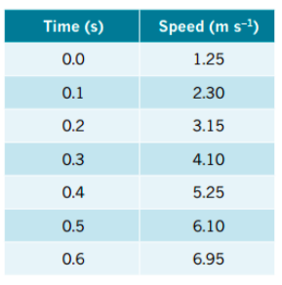

Determine the acceleration graphically.

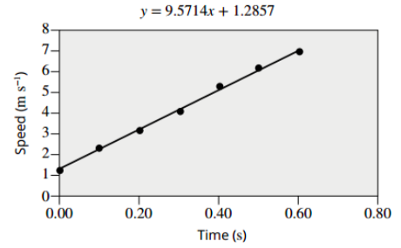

The data is assumed linear with the relationship
v = u + at, which can be thought of as being
v = at + u, which makes it clear that putting v on the
vertical axis and t on the horizontal axis gives a
linear graph with gradient a and vertical intercept u.

i.e. v ∝ t

The regression line as y = 9.57x + 1.2857. If this is rearranged and the constants are suitably
rounded, the equation is v = 1.3 + 9.6t.

This indicates that the ball was moving at 1.3 ms^{–1} at the commencement of data collection
and the ball was accelerating at 9.6 ms^{–2}.

Manipulating Non-Linear Data

Suppose we were examining the relationship between two quantities B and d and had good reason to believe that the relationship between them is

where k is some constant value.

i.e.

Hence plotting B against will produce a linear graph, with the gradient equal to the
constant k.

Example

Some students were investigating the relationship between current and resistance for a new solid-state electronic device. They obtained the data shown in the table.
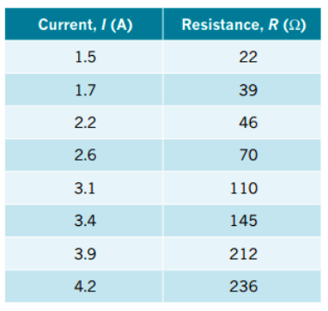
The students believed that the relationship between i and
R is:

R = di ³ + g

where d and g are constants.

i.e. R ∝ i³

∴ Plot R against i³.

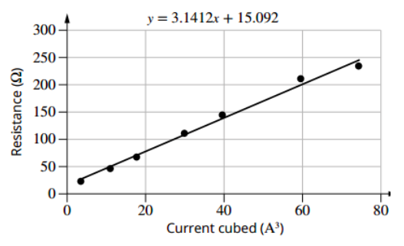
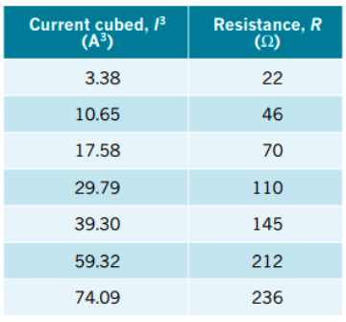

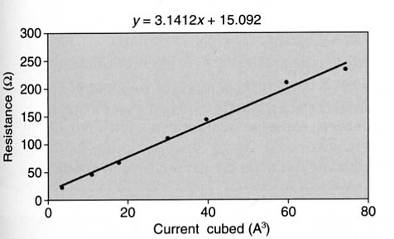
The regression line has the equation y = 3.1x + 15.1.

∴ The equation relating i and R is R = 3.1i³ + 15.1.

Hence, the value of d is 3.1 Ω A^{–3} and the value of g is 15.1 Ω.

Note

In all graphs, it is possible to plot the error bounds associated with each piece of data. The line of regression (or "line of best fit") should go through these error bounds.

If a point does not do this, it is considered an "outlier" and can be removed from consideration when determining the line of regression.

